**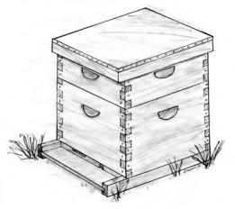[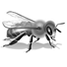](http://capitalbeekeepers.org/)**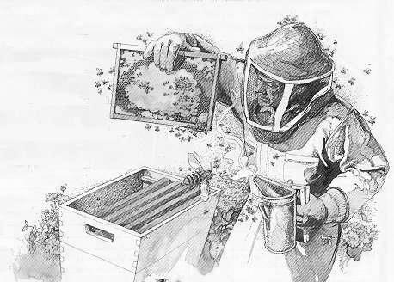

**CAPITAL AREA**

**BEEKEEPERS’**

**ASSOCIATION**

**INVITES YOU TO ATTEND**

**“Beekeeping 101”**

**Friday, March 1, 2019**

**7:00 PM**

**State Farm Show building – Monongahela Room**

**2300 N Cameron St**

**Harrisburg, PA 17110**

**Cost / $5.00 per person**

*Please check website in case of blizzard.*

*http://capitalbeekeepers.org*

**In addition to this beginners’ class, we highly recommend you attend the CABA Short Course.**

In early spring we offer a **2-Day Short Course on Beekeeping** covering all aspects of the craft from A to Z. Taught by our most experienced members, the class is very popular and draws attendees from all around the mid-Atlantic states to hear from scientists and researchers about the latest findings in bee science and colony management study.

***\*Those attending this meeting will receive a $5.00 credit toward the CABA Annual Short Course for this year (2019).***

**Beekeeping Facts:**

* The Bible commands us   
  to eat honey in Proverbs 24:13.
* A queen can lay more than 1500 eggs per day!
* Beeswax is secreted from the body of the bee.

C:\Program Files\Microsoft Office\MEDIA\OFFICE14\Lines\BD10290_.gif

*“If the bee disappears from the surface of the Earth, man would have no more than four years left to live.”*

*- Albert Einstein*

|  |
| --- |
| [**Capital Area Beekeepers’ Association**](http://capitalbeekeepers.org/)  **Serving Beekeepers Throughout Central Pennsylvania** |
|

CABA meets monthly at the Farm Show Complex in Harrisburg, PA.

Each meeting (usually on the third Friday of the month March - November) features expert presentations that cover many aspects of beekeeping and provide members with the latest data and know-how.   
The public is always welcome to attend!

If you would like to become a member of the Capital Area Beekeeper’s Association, we invite you to visit our website: <http://cabapa.org>.

Each year CABA helps plan and execute beekeeping related activities at Pennsylvania’s annual Farm Show in January.

Many of our members are instrumental in preparations for the week-long event held at the Farm Show Complex in Harrisburg.

In addition to organizing displays of Pennsylvania’s finest blue-ribbon honey and hive products, CABA members staff a honeybee learning center and demonstrate honey extraction for the 400,000+ visitors who attend the Farm Show each year.

CABA proudly supports

the activities and mission

of the Pennsylvania State   
Beekeeper’s Association.

You can visit the PSBA website at:  
<http://www.pastatebeekeepers.org>

**Registration Form**

Please use a separate form for each person.

(Copy form as needed.)

**Registration Deadline:**

**Monday, Feb 22, 2019**

Name:

Address:

City / State:   
Zip Code:

County:

Phone: ( )

Email:

**Registration Fee  
$5.00 / person\***

**Make checks payable to:**

Capital Area

Beekeepers’ Association

**Mail to**: Linda Klutas

500 Stony Creek Road

Dauphin, PA 17018.

(717) 921-8660

E-mail - [lklutas@gmail.com](mailto:lklutas@yahoo.com).

**“BEEKEEPING 101”**

**7:00 pm – Greeting & Introduction**

**7:15 pm – Topics of Discussion:**

* Is beekeeping for me?
* What is a bee hive?
* Where to buy all this stuff?
* Where & when do I get bees?
* When should I begin?
* What will this hobby cost?
* Where can I put a bee hive?
* How do I install and feed package bees?
* Do I need a mentor?
* How much honey will my bees make?

**8:30 pm – Question and Answer Time**



Honeybees have caught a lot of attention in recent days with news headlines of “Colony Collapse Disease (CCD)”, “Killer Bees”, “Varroa Mites”, and “Pesticide Usage”. In doing so, they have rekindled an interest in a long-forgotten traditional pastime known as “Beekeeping.”

If you are one of the many folks that want to help the bees and you are considering becoming a beekeeper… then this meeting is for YOU, **the beginner**!

We hope to share with you the information you will need to get started as a beekeeper. You will receive handouts that will help guide you in the purchase of equipment as well as about the bees themselves!

There will be an opportunity for you to ask any questions that you might have in regards to keeping bees.

**We ask that you** **please pre-register for the meeting so we can provide handouts for everyone**.